In Memory
of the 24 British Soldiers
Who were killed in action
4th – 6th November 1918
Buried at Wargnies Le Grand Churchyard.

A commemoration of their sacrifice
4th November 2018

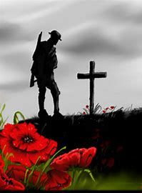

En mémoire
des 24 soldats britanniques
Qui a été tué au combat
4 - 6 novembre 1918
Enterré au cimetière de Wargnies Le Grand.

Une commémoration de leur sacrifice
4 novembre 2018

10:30 Meet at the town Hall

11am Procession to the Garden of Remembrance

Welcome by Mrs. Morel, Mayor of Wargnies le Grand -

Short talk about the history of the battle on 4th and 5th November 1918 during which the soldiers were killed Bernard Beaufort

“Let us commemorate those who have died in the service of our country and its cause.”
The names of the soldiers – read by Stephen Meyer

Private Wilfred John Godfrey BEDNALL age 19 from Leeds
Lce Corporal Frank Sydney BEE age 21 from Radcliffe on Trent
Private Thomas BERRY age 20 from Bradford
Private George BRUNT age 20 from Daventry
Private Ernest BUTROID age 23 from Babworth, Nottinghamshire
Sergeant Horatio John CANTY age 26 from Market Rasen, Lincolnshire.
Private Harry CROPPER age 20 from Manchester
Private Thomas Glyn DAVIES age 19 from Swansea
Private Reginald Thomas DUNSTAN age 31 from Exeter, Devon
Sergeant Robert Edward GREEN age 26 from Stoke on Trent
Private James Arthur GRIFFIN age 19 from Birmingham
2nd Lieutenant Robert Edward HARRIS age 22 from Hanley, Staffordshire

2nd Lieutenant Robert Edward HARRIS age 22 from Hanley, Staffordshire
Private John MAITLAND age 19 from Pittington, Durham
Private William McCREE age 24 from Nottingham
Lce Corporal David William Adams McLACHLAN age 29 from Egremont, Cheshire
Private William Thomas MOOR age 21 from Wisbech, Cambridgeshire
Private George Edward MOORE age 21 from Syston, Leicestershire
Private Albert Edward REDFORD age 26 from Birmingham
Serjeant James REILLY age 20 from Scotland
Private Campbell SHIRTCLIFF age 20 from Sheffield
2nd Lieutenant Lionel Percy TATE age 26 from Newcatle on Tyne
Private Harold WADSWORTH age 23 from Manchester
Private George Samuel WILLCOCKS age 39 from London
Private George WILLOUGHBY age 20 from Wolverhampton

Réunion à 10:30 heures devant la mairie

11:00 Départ en cortége vers le jardin du souvenir

Accueil par Madame Morel , Maire de Wargnies le Grand

Un rappel historique des combats des 4 et 5 novembre 1918 au cours desquels les soldats ont été tués
Bernard Beaufort

«Souvenons-nous de ceux qui sont morts au service de notre pays et de sa cause .
Lecture des noms des soldats

Private John MAITLAND age 19 from Pittington, Durham
Private William McCREE age 24 from Nottingham
Lce Corporal David William Adams McLACHLAN age 29 from Egremont
Private William Thomas MOOR age 21 from Wisbech, Cambridgeshire
Private George Edward MOORE age 21 from Syston, Leicestershire
Private Albert Edward REDFORD age 26 from Birmingham
Sergeant James REILLY age 20 from Scotland
Private Campbell SHIRTCLIFF age 20 from Sheffield
2nd Lieutenant Lionel Percy TATE age 26 from Newcastle on Tyne
Private Harold WADSWORTH age 23 from Manchester
Private George Samuel WILLCOCKS age 39 from London
Private George WILLOUGHBY age 20 from Wolverhampton

Private Harold WADSWORTH age 23 from Manchester
Private George Samuel WILLCOCKS age 39 from London
Private George WILLOUGHBY age 20 from Wolverhampton

Dedication to Private Reginald Thomas DUNSTAN – Gerry Dunstan

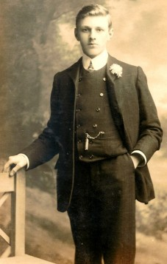
You lived and fought alongside your comrades until that fateful day, 4th November 1918.
You have lain here with those comrades for 100 years with no visitation from
your family. Your loved-ones have all passed on but we your grandchildren
are proud to be here. You are in our Family Tree Book where future
generations will see you. You will never be forgotten. Thank you for our
lives and thank you for your sacrifice.

Private George Samuel WILLCOCKS – Steve Barrett

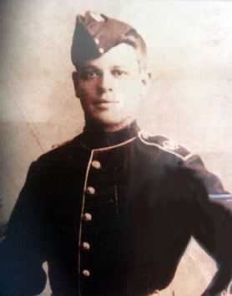
Hello, my name is Steve Barrett and my Great Grandfather was George Samuel Willcocks who rests in your churchyard in last grave on the right.

I am here to honour his memory, and those of the other 23 brave soldiers resting with him, with my father and 3 of his Great Great Grandchildren, being 3 of my five children.

George was the eldest of our 24 having been born on March the 2nd 1879 in Hackney, East London. He was married to Minnie Payton and they had 8 children together, of which 5 survived; he was remembered as a happy family man.

Before war broke out he served briefly with The Royal Marines and re-enlisted in the Machine Gun Corps of the 7th Battalion Rifle Brigade on 31st August 1914.

During his service he fought in many major battles on the Somme before sadly being the last of our 24 to be killed in action on 6th November 1918. He was 39 years of age.

2nd Lieutenant Lionel Percy TATE – Jenny Cowling

24 British soldiers lie in peace here. Before the war they were all living ordinary lives with their parents and siblings in their home towns, all around Great Britain. My Grand-uncle Percy was one of them, I’d like to tell a little of his story, but it could easily be the story of any one of these men.

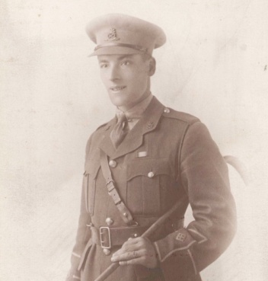

Percy was born in Newcastle on Tyne in April 1892. He was the eldest child of Robert William & Emma Tate. He certainly grew up in a bustling noisy household, with 8 younger siblings! Before the war he worked as a clerk in the chief accountant’s office of a famous ship building company.

He enlisted in the Territorial Army in February 1913 and on the outbreak of war was assigned to the Northumberland Hussars, cavalry. His was the first territorial regiment to be sent overseas; they arrived at Zeebrugge on 5th October 1914. They took part in many terrible battles, including the 1st battle of Ypres in 1914, the battle of Loos in 1915, the Somme in 1916, then during 1917 the 3rd battle of Ypres, which is also known as Passchendaele.

By this time Percy had been promoted to the rank of Corporal. January 1917 was bitterly cold and many soldiers suffered due to the poor conditions in the trenches. Percy was taken to the Field Ambulance hospital suffering from inflammation of the face and his future comrade Robert Harris, suffered from trench foot.

I’d like to read you an extract from a poem written during that very harsh winter by the famous poet Wilfred Owen. It seems appropriate, because he was also killed in action exactly 100 years ago today and is buried not far from here at Ors.

Our brains ache, in the merciless iced east winds that knife us…
Wearied we keep awake because the night is silent…
Low, drooping flares confuse our memory of the salient…
Worried by silence, sentries whisper, curious, nervous,
But nothing happens.
Watching, we hear the mad gusts tugging on the wire,
Like twitching agonies of men among its brambles.
Northward, incessantly, the flickering gunnery rumbles,
Far off, like a dull rumour of some other war.
What are we doing here ?
The poignant misery of dawn begins to grow…
We only know war lasts, rain soaks, and clouds sag stormy.
Dawn massing in the east her melancholy army
Attacks once more in ranks on shivering ranks of gray,
But nothing happens.
Sudden successive flights of bullets streak the silence.
Less deathly than the air that shudders black with snow,
With sidelong flowing flakes that flock, pause, and renew ;
We watch them wandering up and down the wind’s nonchalance,
But nothing happens.
Pale flakes with fingering stealth come feeling for our faces —
We cringe in holes, back on forgotten dreams, and stare, snow-dazed,
Deep into grassier ditches.
— Is it that we are dying ?
Tonight, this frost will fasten on this mud and us,
shrivelling many hands, puckering foreheads crisp.
The burying-party, picks and shovels in shaking grasp,
Pause over half-known faces. All their eyes are ice,
But nothing happens.

Percy returned to England in October 1917 to attend officer cadet school and was he was offered a commission with the 8th Battalion North Staffordshire Regiment. He joined them in May 1918, taking part in the battle of Aisne and ultimately the final push into Picardy. Percy’s younger brother Norman was declared missing in action on 6th October 1918, but the confirmation of his death did not come until after the armistice.

It is impossible for us to imagine the terrible things that Percy and the other soldiers must have witnessed during those 4 years of war. After surviving so much, I feel so sad that he was killed within only a few days of the end of the war. It was a tragedy for his fiancée, Cissy Dryden, who never married and always kept his photo. It was also shattering news for his family. I am glad that some of us have been able to come here today to remember him and his comrades in this peaceful place where they rest. I would also like to thank all the people of Wargnies le Grand for watching over them and especially those who helped to make today’s remembrance ceremony possible.

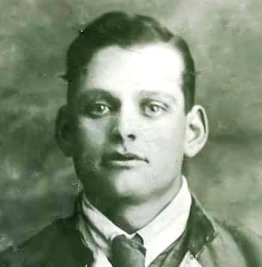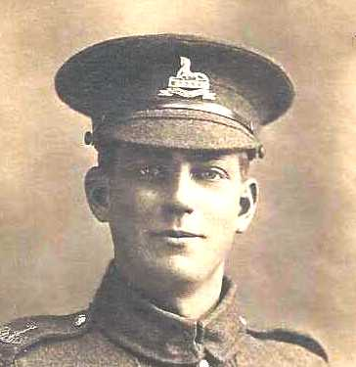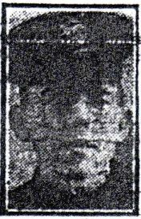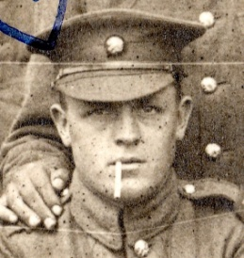
We also remember Ernest Butroid, Horatio Canty, George Moore & Frank Bee

The Exhortation – Mike Moore
“They shall grow not old, as we that are left grow old,
Age shall not weary them, nor the years condemn.
At the going down of the sun, and in the morning,
We will remember them”.
Response by all:
“We will remember them”.

The laying of wreaths

The minute of silence

The blessing of the graves by a member of the parish community

Acte du Souvenir
Ils ne vieilliront pas comme nous, qui leur avons survécu.
Ils ne connaîtront jamais l'outrage ni le poids des années.
Quand viendra l'heure du crépuscule et celle de l'aurore,
nous nous souviendrons d'eux.
Réponse de tous:
Nous nous souviendrons d'eux.

Le dépot des gerbes de fleurs et des couronnes

La minute de silence

La bénédiction des tombes par un membre de la communauté paroissiale
Kohima Epitaph – Mike Moore
“When you go home, tell them of us and say, for your tomorrow, we gave our today”

“Quand tu reviendras à la maison,
parle-leur de nous et dis-leur,
Pour votre demain, nous avons donné notre aujourd'hui”

The national anthems - Les hymnes nationaux

La Marseillaise
Allons enfants de la Patrie
Le jour de gloire est arrivé!
Contre nous de la tyrannie
L'étendard sanglant est levé
L'étendard sanglant est levé
Entendez-vous dans les campagnes
Mugir ces féroces soldats?
Ils viennent jusque dans vos bras
Égorger vos fils, vos compagnes!
Aux armes, citoyens
Formez vos bataillons
Marchons, marchons!
Qu'un sang impur
Abreuve nos sillons!

God save the Queen
God save our gracious Queen
Long live our noble Queen!
God save the Queen!
Send her victorious,
Happy and glorious,
Long to reign over us:
God save the Queen!

